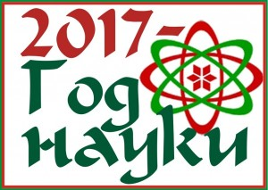 |  |  | 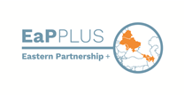 | 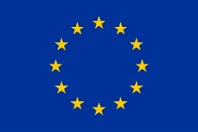

DIASPORA WORKSHOP ON QUANTUM TECHNOLOGIES
21 November 2017, Minsk, Belarus
Venue: TBC
ANNOUNCEMENT & INVITATION
The project 'Science, Technology and Innovation International Cooperation Network for Eastern Partnership Countries Plus (EaP PLUS, https://www.eap-plus.eu) aims to stimulate cooperation between researchers from the EaP countries and EU member states and enhance participation of the Eastern Partnership countries in Horizon 2020 Framework Programme. Targeted cooperation with scientific diaspora is considered to be one of the ways to reach this goal. To facilitate networking and discuss opportunities for joint applications to HORIZON 2020 calls for proposals in 2018-2020, EaP PLUS is going to organize six ‘diaspora workshops’, one in each EaP country.
In Belarus, the diaspora workshop will be held on 21 November 2017 with a focus on quantum correlations and their application for quantum technologies. The event is embedded in the program of the XV International Conference on Quantum Optics and Quantum Information (20–23 November 2017, Minsk) that, in its turn, is part of the YEAR OF SCIENCE – 2017 agenda.
The aim of the workshop is
- to contribute to strengthening of existing links with compatriots working in the EU and setting up new partnerships,
- foster knowledge exchange and intensify collaboration,
- stimulate joint grant applications to HORIZON 2020 and COST in thematic areas of the workshop.
Workshop organizers:
- B.I.Stepanov Institute of Physics of the National Academy of Sciences of Belarus, http://ifan.basnet.by
- Belarusian Physical Society
- Belarusian Institute of System Analysis and Information Support of Science and Technology (BelISA), http://belisa.org.by, EaP PLUS partner
Participants:
- Representatives of Belarusian scientific diaspora residing and working in the EU and interested in collaboration with their colleagues in Belarus in the focus and connected areas, in particular within the framework of EC-funded programmes. For the purpose of the Workshop we consider the broadest possible definition of diaspora, including scientists of Belarusian origin, expats and Belarusian citizens working abroad for long time or just temporarily;
- Local researchers from the academic sector and knowledge based industry interested in developing/strengthening links with their compatriots from EU and applying to HORIZON 2020 and COST.
Form of participation: 15-20’ presentation of research results, participation in the round table discussion.
Languages: Russian, English (translation is not foreseen)
Participation in the XV International Conference on Quantum Optics and Quantum Information: in addition to the Workshop, diaspora representatives are invited and welcome to take part in the core events of the XV International Conference on Quantum Optics and Quantum Information subject to the separate registration: http://master.basnet.by/icqoqi2017/. Deadline for registration is 1 October 2017.
Travel grants for diaspora representatives: BelISA will cover travel and accommodation costs of limited number of Workshop participants from EU, including:
- Flight/train ticket to/from Minsk (economy class)
- If needed, accommodation for duration of max 4 nights to allow taking part in the Conference.
Registration: To register, please, fill in a registration form and send it to registration@belisa.org.by.
Deadlines for registration:
- for diaspora representatives – 1 October 2017, however the earlier informal notification of organizers about the intention to take part in the Workshop is extremely welcome!
- for local participants willing to present their topic of research – 1 October 2017
- for local participants without presentation – 3 November 2017
Contact persons:
In the Institute of Physics –
- Dr. Dmitry Mogilevtsev +375 17 284 10 23, d.mogilevtsev@ifanbel.bas-net.by
In BelISA –
- Olga Meerovskaya, +375 17 2033139, meerovskaya@fp7-nip.org.by
- Katherine Skuratovich, +3875 17 2094326, skuratovich@belisa.org.by

